# Use Cases

## Create account

**BASIC COURSE:**

Upon opening the website, the user will be prompted to create an account through one of their social media accounts.

**ALTERNATE COURSES:**

**The User does not want to create an account initially:** The user will navigate to the settings page and click a button that says sign up / login. Once this button is clicked, it will take them to a new page where the user will be prompted to use any of various social media accounts they have in order to sign in/ create an account. If they forgot their password, then they have to use their social media account password assistance to recover their password.

**Robustness Model/Diagram:**

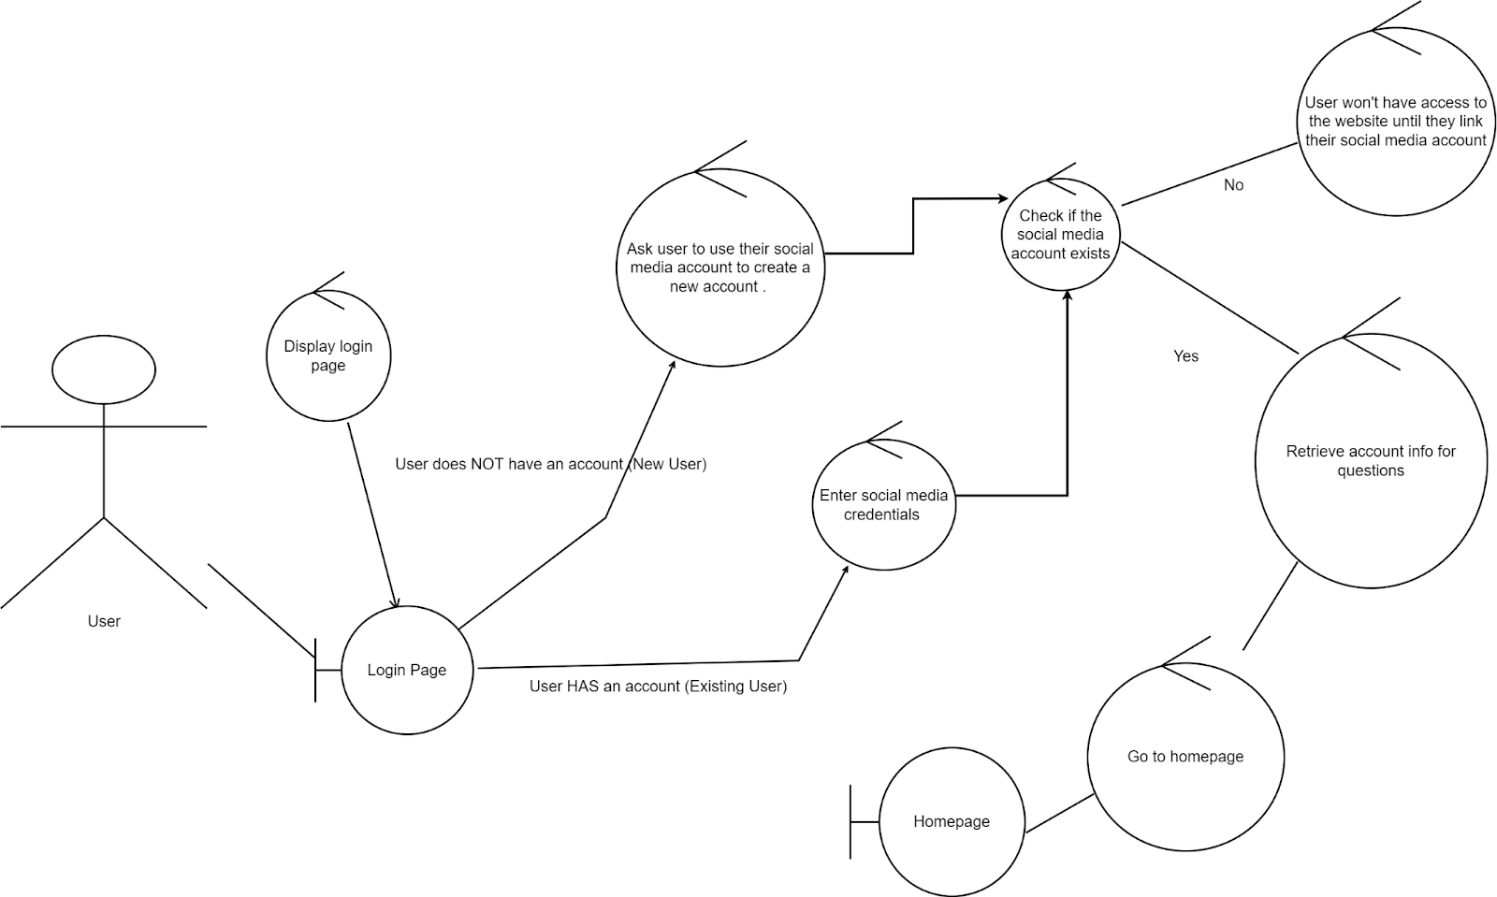

## Choose a topic of lessons to work through

**BASIC COURSE:**

From the homepage on the website, the users tap on the lessons button and will be taken to a new page where the users can choose the lessons of the topic they want to work on.

**Robustness Model/Diagram:**

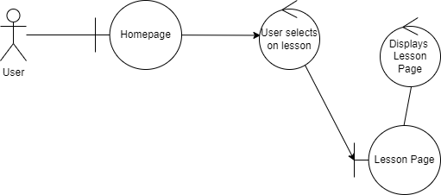

## Select a specific topic from a lesson to work on

**BASIC COURSE:**

Once the user chooses that particular lesson, they will be taken to a new page to select and learn a specific topic from that lesson. For example, if they choose the lesson “Data Types”, then the user can click the “Topics” button, and scroll through the various topics that talk about the different kinds of data types we see in the computer science field. Once they find a topic that interests them, then they can select that specific topic to learn more about it.

**Robustness Model/Diagram:**

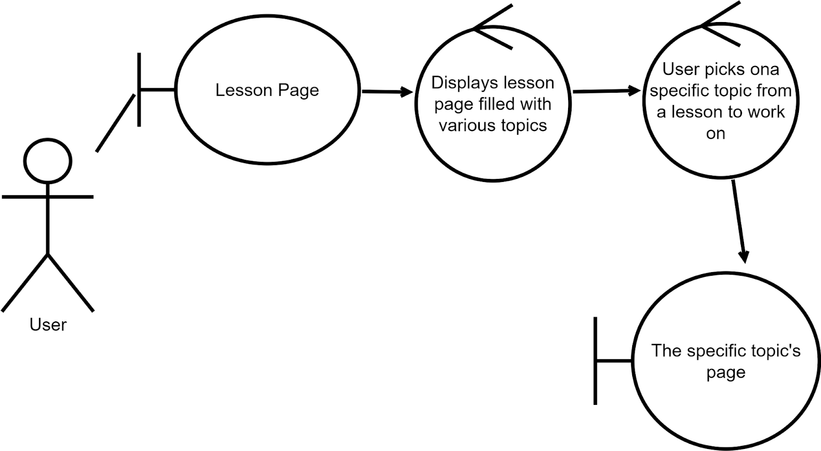

## 

## Working through a lesson

**BASIC COURSE:**

Lessons will be broken up into sections,and the user will be able to scroll through the sections and select the one they would like to work on. Once the User has selected a section they would like to work on they will be able to read the information they will need to solve the section at the top of the page and then there will be a question for them to answer at the bottom of the page. The question at the bottom of the page will either require them to write code that produces an output that can be tested or there will be a fill in the blanks or multiple choice for them to answer to complete the section.

**Robustness Model/Diagram:**

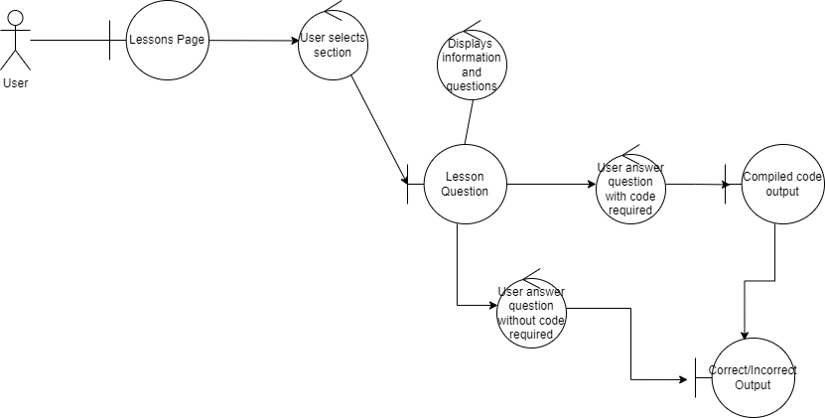

## Tutorial

**BASIC COURSE:**

Upon first opening the website, users are greeted with a message prompt asking if they want to go through a quick tutorial that helps them familiarize with the website. By clicking on the “OK” button, users will enter the tutorial.

**ALTERNATE COURSE:**

**User clicks on the “No Thanks” button:** The message will be dismissed. Now the User will have to navigate to the “Account & Settings” page to complete this tutorial.

**Robustness Model/Diagram:** 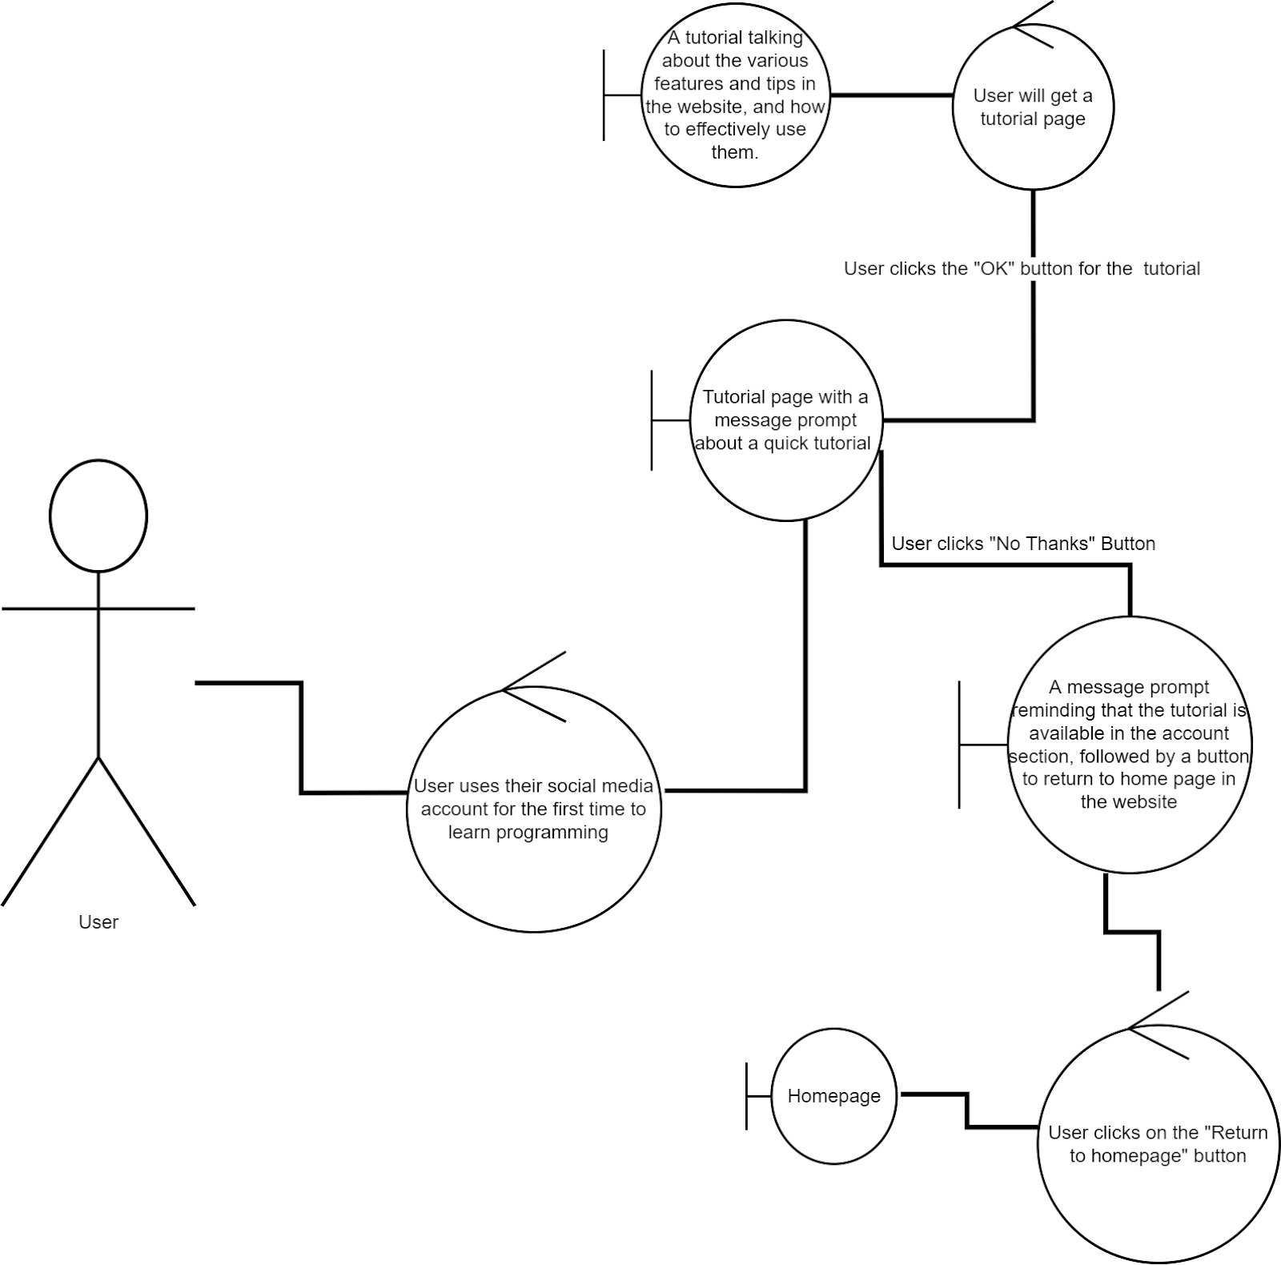

## Answer practice question

**BASIC COURSE:**

After completing one lesson, the user will be given a practice question, which is a multiple choice question that helps memorization. Users can tap on one of the options and a result will appear based on the user's selection. If the user chooses the correct answer, there will be a message congratulating the user.

**ALTERNATE COURSE:**

**User chooses the wrong answer:** There will be a message asking user to try again,

and provide a free hint to help users.

**Robustness Model/Diagram:**

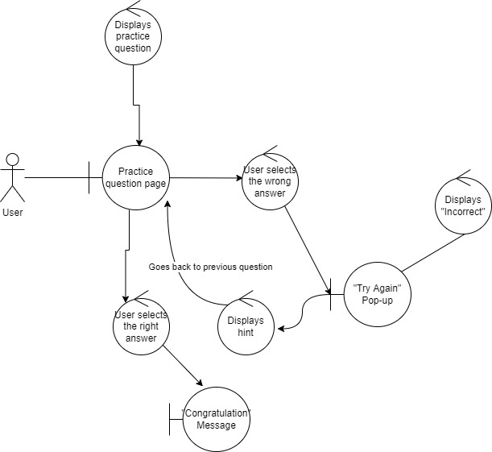

## Change settings

**BASIC COURSE:**

User goes to settings by tapping the button on the homepage or the gear icon on the top left corner. On the settings page, the user changes the theme for the app and the font of the text. Before returning to the homepage, the user taps the “save” button to save the changes.

**ALTERNATE COURSE:**

**User does not tap the “save” button and taps the return button:** A prompt pops asking the user if they want to save or discard the changes, if the user taps “save”, the changes will be saved. If the user taps”discard”, all changes made will not be saved.

**Robustness Model/Diagram:**

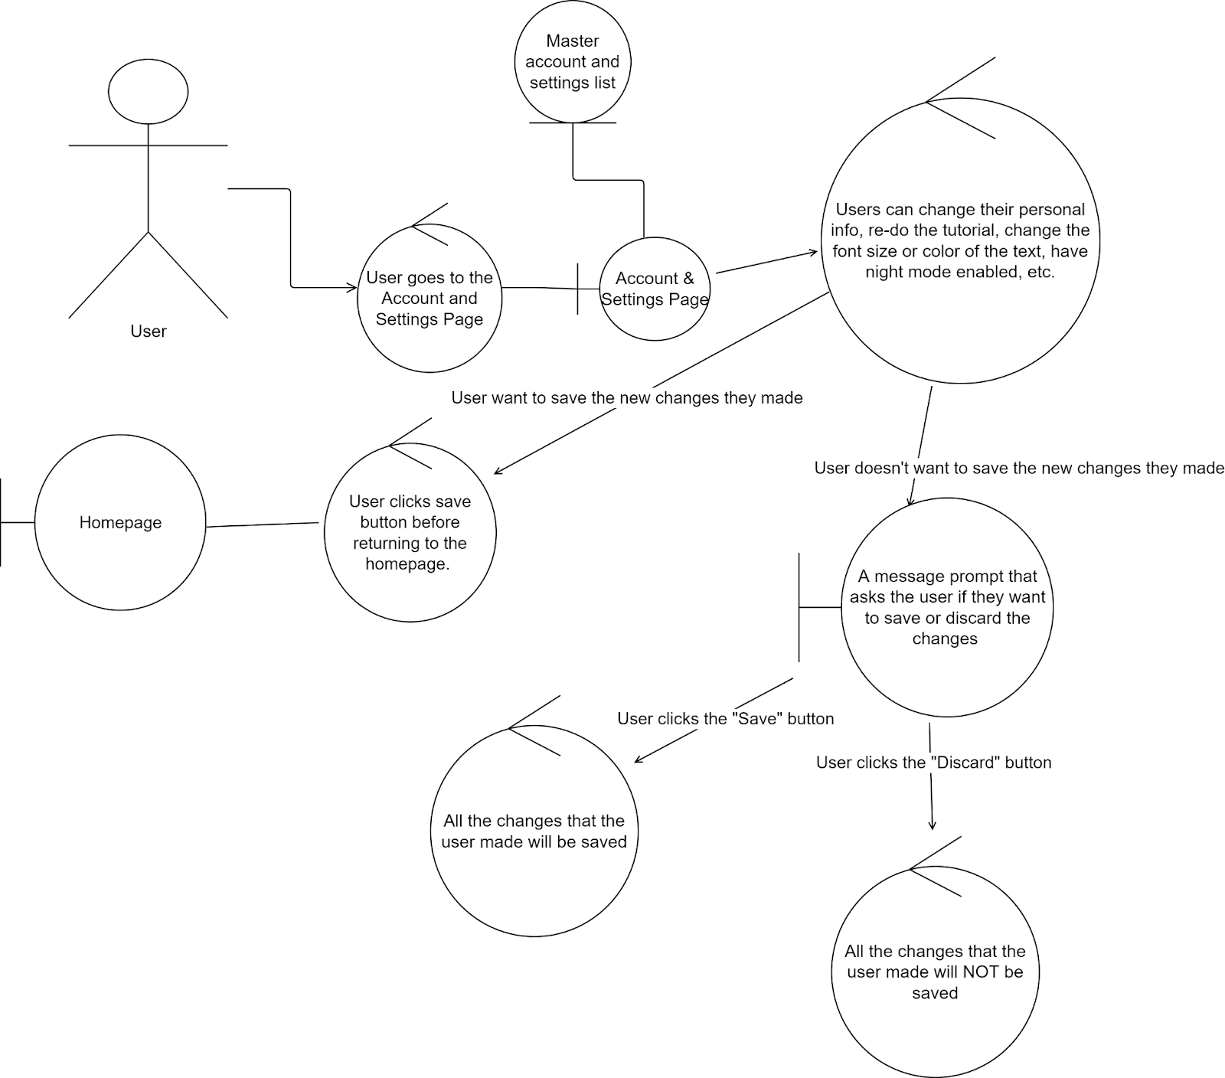

## Take quiz based on lesson

**BASIC COURSE:**

Once the User selects a lesson a quiz will be displayed at the top of the page above all the sections for the lesson. The User will click the quiz button and receive a set of questions based on the section of the lesson. User selects the question and starts working on it. The user can go back to the question sets to select their desired question. Once the user is done with all the questions in the set, there will be a “Finish” button on the last question. When the user presses the button, the results page will be displayed with the amount of questions the users got wrong or right.

**Robustness Model/Diagram:**

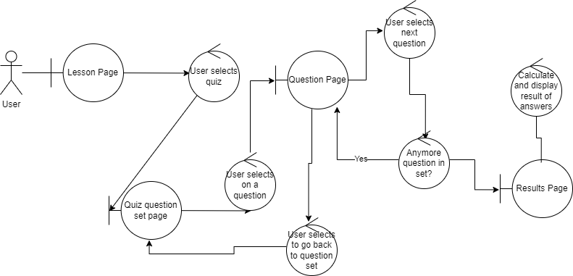

## Comment under a question

**BASIC COURSE:**

While working on a question, user can scroll down to see the comments about the question. After successfully completing the question, user will be able to view all the comments, including the ones that has answers to the question. User can also write down comments after completing the question. When scrolling down, more comments will be loaded.

**ALTERNATE COURSE:**

**User tries to write down comments before completing the question**:

A message will show up asking user to solve the problem before writing down any comments.

**User writes down answers to the question in the comment:**

A message will show up when the user clicks submit comment, telling user that their comment will not be visible to those working on the problem until they have successfully completed the problem.